**CONSTANTS AND MACROS**

1. Write a function macro to find the smallest number in an array of integers

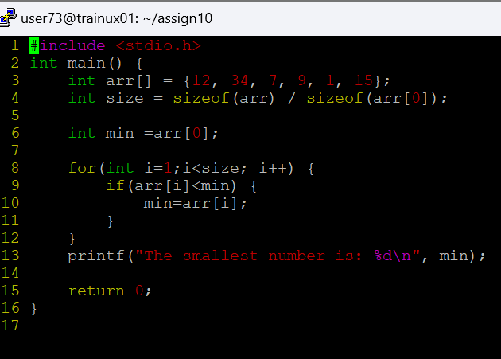

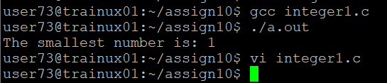

**2. What are the differences between macros and constant. Can you replace a constant with a macro and vice versa? Give examples for your statements**

**Macro:** A macro is a preprocessor directive that defines a name to represent a piece of code, usually a value or expression, and gets replaced by the preprocessor before the program is compiled.

* **Defined using #define.**

**Constant:** A constant is a variable that cannot be modified once it is initialized. It is a type-safe feature and is part of the program during runtime.

* **Defined using const.**

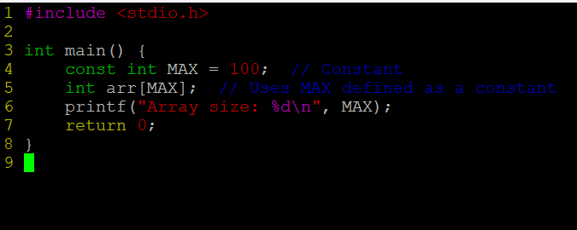

**3. Refer macro below**

**#define MYPROD(x) (x *x)**

**WAP to invoke the above macro with inputs as below and display the result.**

**a. MYPROD(2+1)**

**b. MYPROD(6+1)**

**Do you get the expected answers as 9 and 49 in case a. and case b.?**

**If not modify the code to produce the expected results. in above case**

**A: Modified code:**

**4. Write macro definitions with arguments for calculation of area of a triangle and circle.**

**a. Use macros for both constants as well as formula evaluations.**

**b. Store these macro definitions in a header file and invoke the macros from the main function.**

5. Define a macro name MYPRINT as below.

#define MYPRINT(x) printf(x)

Use the above macro conditionally only if a macro CUST_PRINT is defined , otherwise not to be used.

For eg refer the code and comments below.

int main()

{

MYPRINT("Hello World"); // will be displayed only when CUST_PRINT is defined

printf("Test"); // will be displayed always irrepective of CUST_PRINT

return 0;

}

Add the code to demonstrate the above behaviour.

**6**. Identify and use the macros to display

a. file name

b. function name

c. line of code

Show the usage with a code example

